GITAM 

(DEEMED TO BE UNIVERSITY)

TITLE:PCB WORKSHOP

SUB TITLE :ANALOG AND DIGITAL

ECE DEPARTMENT

TEAM MEMBERS

NAMES:

N.KEERTHI (BU21EECE0100410)

HIMA BINDU (BU21EECE0100 )

KANIKI CHAKRADHAR REDDY (BU21EECE0100170)

SAI JAYANTH (BU21EECE0100 )

PCB WORKSHOP

ANALOG CIRCUIT

Simulation results for Low Pass Filter:

Components Required:

1.Bread board-1

2.Capacitors

3.Resistors

4.Op-amp

5.Power Supply

6.Connecting Wires

7.CRO 20/30Mhz

8.Probes

CIRCUIT DIAGRAM:

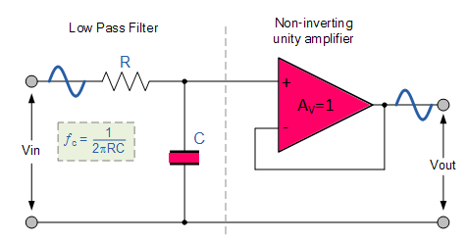

Procedure:

1. **Prepare Breadboard:**
   * Place the breadboard on a stable surface.
2. **Insert Components:**
   * Insert capacitors and resistors into the breadboard as per the circuit diagram.
3. **Integrate Op-Amp:**
   * Insert the op-amp into the breadboard according to the circuit layout.
4. **Wire Power Supply:**
   * Connect the positive and negative terminals of the power supply to the breadboard's power rails.
5. **Connect Components:**
   * Use connecting wires to establish connections between the components based on the circuit diagram.
6. **Power On:**
   * Turn on the power supply to provide power to the circuit.
7. **CRO Setup:**
   * Set up the CRO (20/30MHz) by connecting its probes to the appropriate terminals of the circuit.
8. **Signal Analysis:**
   * Use the CRO to analyze the signals in the circuit, observing waveform characteristics and frequencies.
9. **Probe Placement:**
   * Attach probes to specific points in the circuit to measure voltage levels and signal waveforms accurately.

Hardware Implementation:

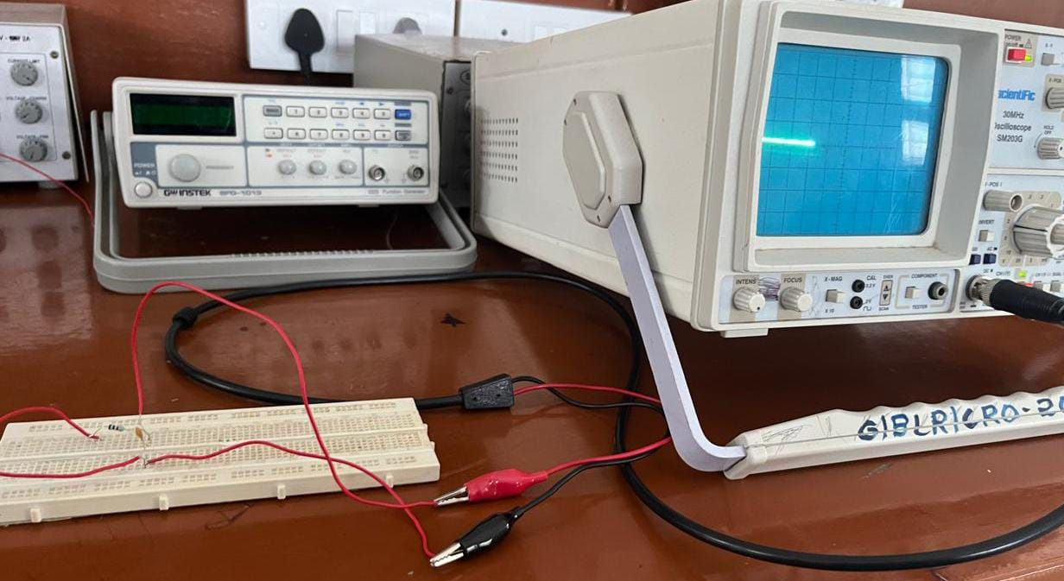

Circuit Schematic in Tinkercad:

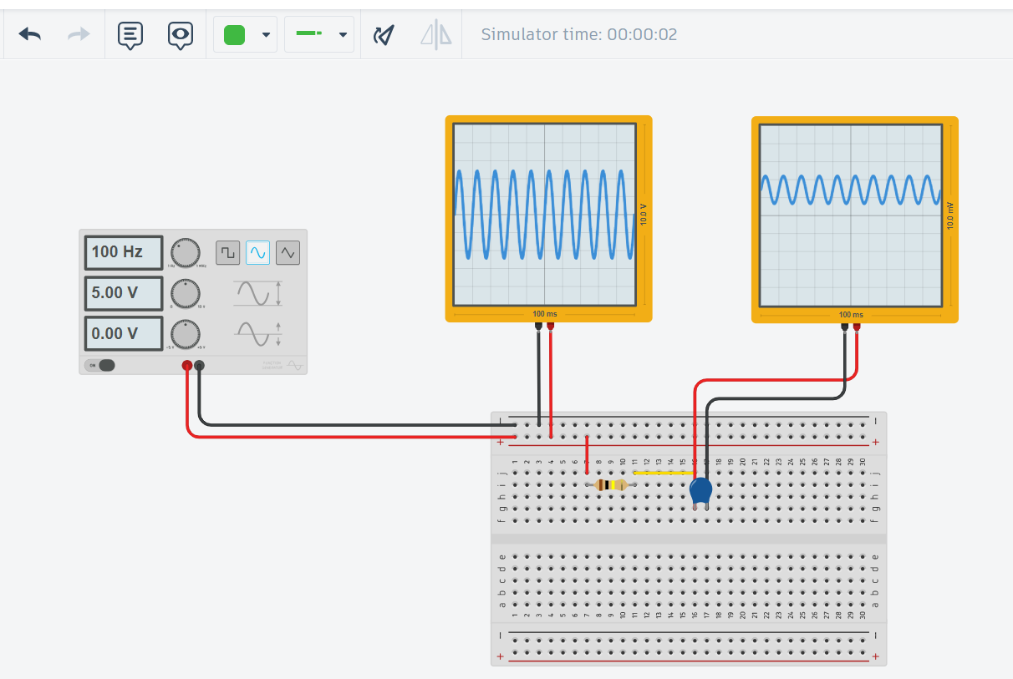

Simulation in Easy Eda:

**Open EasyEDA:** Go to the EasyEDA website and log in.

**Create New Project:** Click "New Project" and name it.

**Open Schematic:** Click "New Schematic" to start.

**Add Resistor:** Search for "Resistor" in the "Libraries" tab and place it on the schematic.

**Add Capacitor:** Search for "Capacitor" in the "Libraries" tab and place it.

**Add Ground:** Search for "GND" and place it.

**Add Voltage Source:** Search for "VSource" and place it.

**Connect Components:** Wire the resistor to the capacitor, the voltage source to the resistor, and ground the capacitor and voltage source.

**Set Values:** Double-click the resistor (set to 1kΩ) and the capacitor (set to 1µF).

**Run Simulation:** Click "Simulate," choose "AC Analysis," set frequency range (10Hz to 1MHz), and run.

**View Results:** Check the frequency response plot to see the filter's performance.

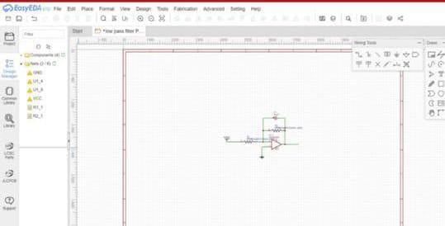

2D View:

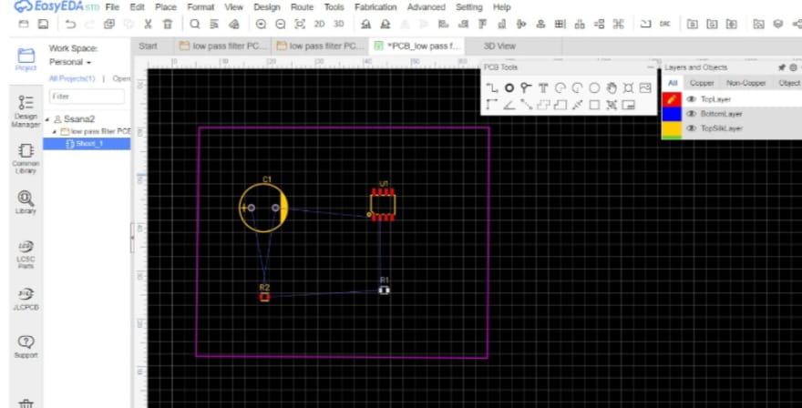

3D View:

